Create a Snapshot of a VM and Test it by loading the Previous Version/Cloned VM using Vmware workstation.
Aim: To create a snapshot of a Virtual Machine in VMware Workstation and verify its functionality by restoring the VM to the previous version/ cloned state using the snapshot.
Procedure:
- Open VMware Workstation on your computer.
- Select the Virtual Machine that you have already created and configured.
- Make sure the VM is in a powered-off or powered-on but stable state before taking a snapshot.
- Go to the VM menu on the top menu bar.
- Click on Snapshot ➜ Take Snapshot.
- Enter a Snapshot Name and an optional description (e.g., “Initial Setup Completed”).
- Click OK to save the snapshot.
- Make some changes inside the VM (example: install software or modify settings).
- To test the snapshot, again go to VM ➜ Snapshot ➜ Snapshot Manager.
- Select the previous snapshot and click Restore (or Go To) to load the earlier version/cloned state and verify changes are reversed.

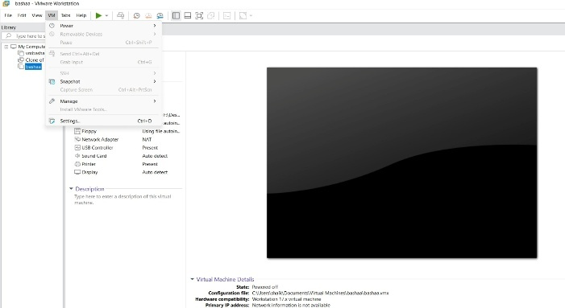
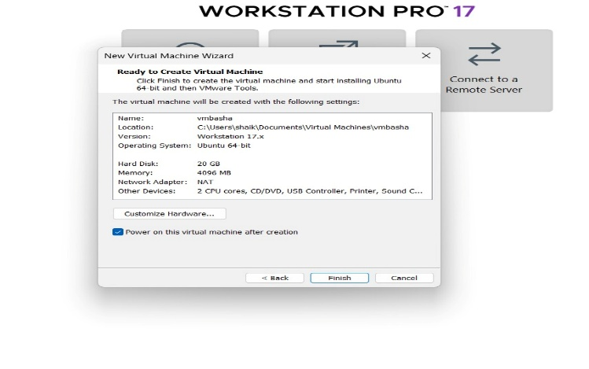
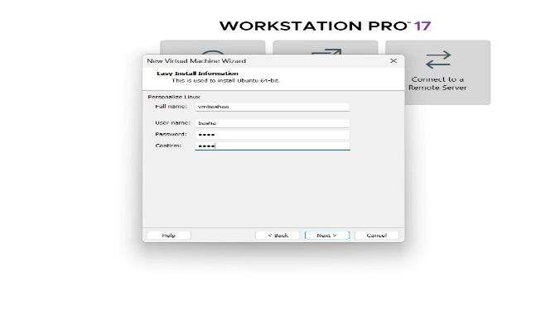
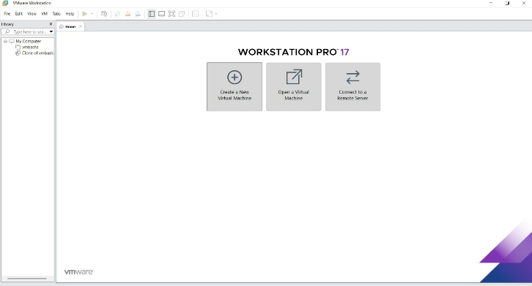
Output:

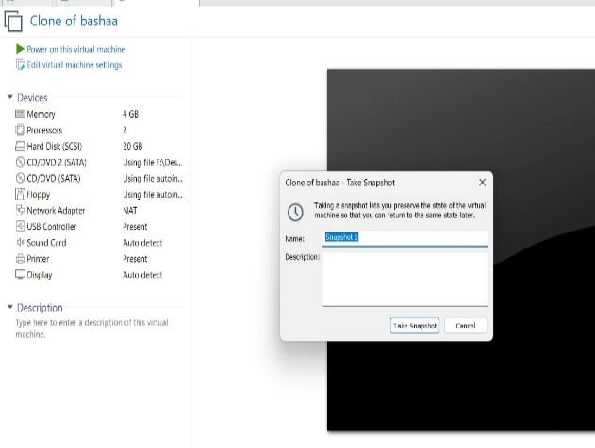
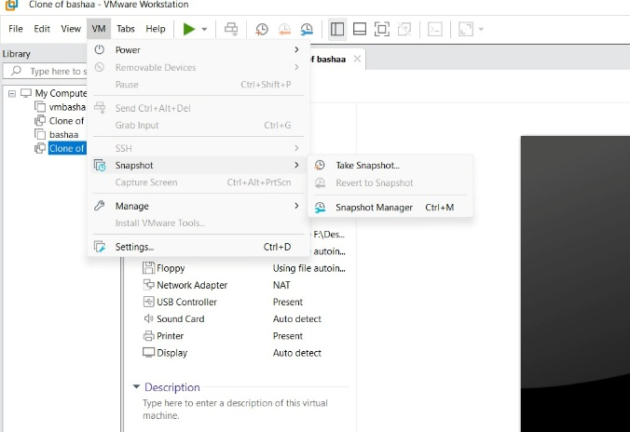

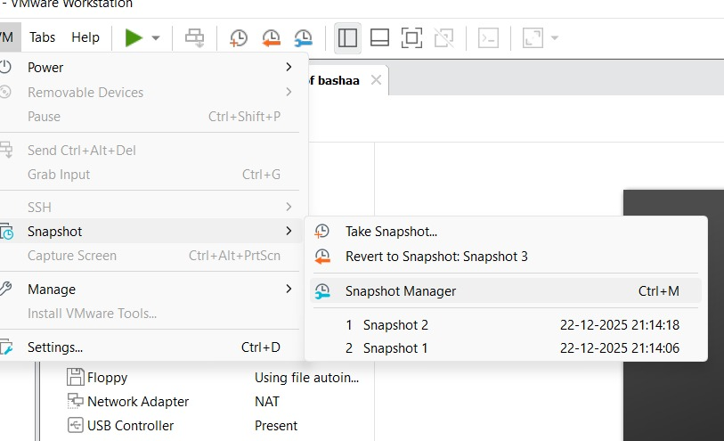
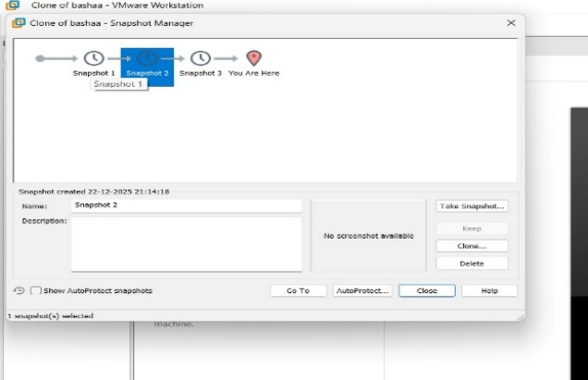

Result: A snapshot of the Virtual Machine was successfully created and restored. The VM returned to its previous state, demonstrating that VMware Workstation supports snapshot-based version control and recovery.

